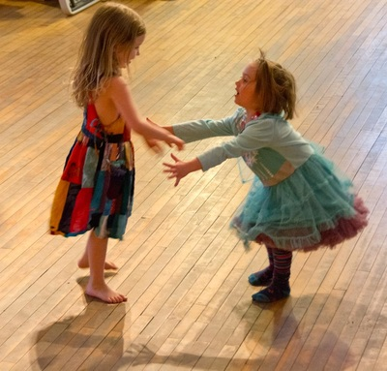
Dance, Sing, and Jump Around!
family dance for all ages-
Live traditional music with young, local musicians
Liz Benjamin, caller
Sunday, November 6, 2016
3:00- 4:30 P.M.
Plainfield Town Hall Opera House on Route 2
Suggested Donation $5/$10 per family
NO ONE turned away!

lizbenjamin64@gmail.com merrykays@yahoo.com www.dancesingandjumparound.weebly.com

With thanks to the Center for Arts and Learning for Fiscal Sponsorship- we can now receive tax-deductible donations!

